Living Prayer
in Service to Others

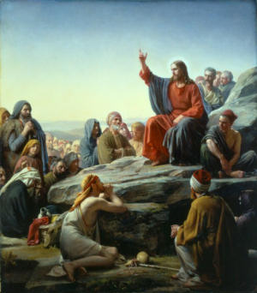
Blessed are the pure in heart, for they will see God.
Blessed are the peacemakers,
for they will be called sons of God.
Blessed are those who are persecuted because of righteousness, for theirs is the kingdom of heaven. Blessed are you when people insult you, persecute you and falsely say all kinds of evil against you because of me.
(Matthew 5:1-12)
Blessed are the poor in spirit,
for theirs is the kingdom of heaven.
Blessed are those who mourn, for they will be comforted.
Blessed are the meek,
for they will inherit the earth.
Blessed are those who hunger and thirst for righteousness,
for they will be filled.
Blessed are the merciful,
for they will be shown mercy.

a series for Fridays in Lent
Presented by
Father John Sullivan M.S.
and Anna Rae-Kelly M.Th, M.Sc.

Time: 7.30 PM, FRIDAYS
February 23, March 2 - 9 - 16 - 23 - 30
Location: Chapel of Reconciliation

For more information:
National Shrine of Our Lady of La Salette
947 Park Street, Attleboro, MA 02705
Tel. 508-222-5410
National Shrine of Our Lady of La Salette
947 Park Street, Attleboro, MA 02705
Tel. 508-222-5410
www.lasalette-shrine.org

www.annaprae.com

