

I will fast for our priests on Saturday, 19 October 2013 from Dawn until 3PM.

NAME:

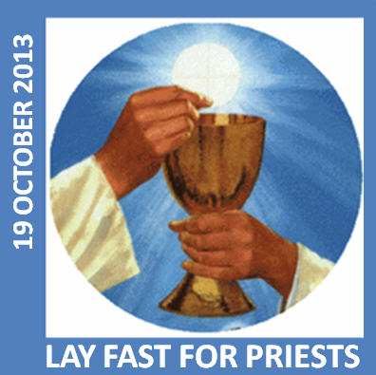

**GLOBAL LAY FAST FOR PRIESTS**

**DATE: SATURDAY, OCT 19**

**TIMES: DAWN UNTIL 3 PM**

**FAST AND PRAY**

**PLACE: Wherever you are**

PLEASE JOIN US ANONYMOUSLY OR SIGN UP ONLINE AT:

**http://www.annaprae.com/layfast2013onlinesignup.html**