***FOURTEENTH, ANNUAL, GLOBAL***

**LAY FAST FOR PRIESTS**

***“Prayer united with suffering is the most powerful force in human history.” – Saint Pope John Paul II***

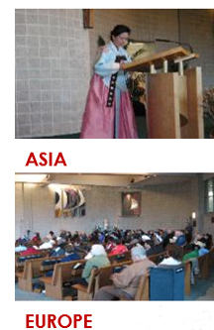 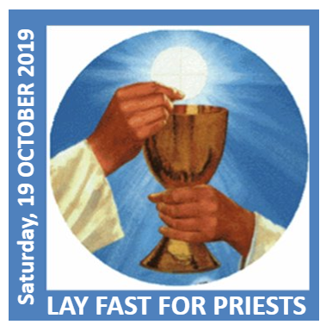 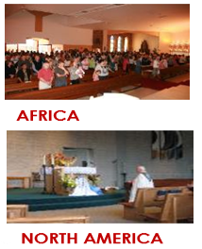

**DATE: SATURDAY, 19 OCTOBER 2019**

**TIME: DAWN UNTIL 3 PM**

**PLACE: WHEREVER YOU ARE**

**Day of fasting and prayer for our priests - past, present and future.**

**TO JOIN THE GLOBAL ARMY OF FASTERS, PLEASE SIGN UP BELOW**

**OR ONLINE AT:**

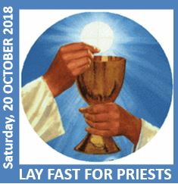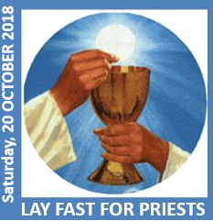

***Please place sign up slip in basket or box provided. Thank you.***

I, (NAME): _________________________________________________________________________________

on **Saturday, 19 October 2019**,from Dawn until 3.00 PM, commit to fast from ___________________________________________________________________________________________

and will offer this up for our priests and for vocations to the priesthood.

***Please complete the SIGN UP SHEET BELOW and TEAR OFF.***

JOIN US ON **TWITTER** @layfast – or - **FACEBOOK** “Lay Fast for Priests 2019”

[](https://twitter.com/layfast) 

**www.annaprae.com**

